|  |  |
| --- | --- |
| **Module** | **Scenario** |
| INV | Move order Creation ->Move order Transfer->Move order Approval |
| INV | Move order Creation ->Move order issue->Move order Approval |
| INV | Move order Approval→Move order Allocations->Transact Move orders |

1. Move order Creation🡪Move Order Transfer-🡪Move Order Approval

Responsibility:

MPC INVENTORY SUPERUSER

**1.Select Move order menu, Organization as RPM.**

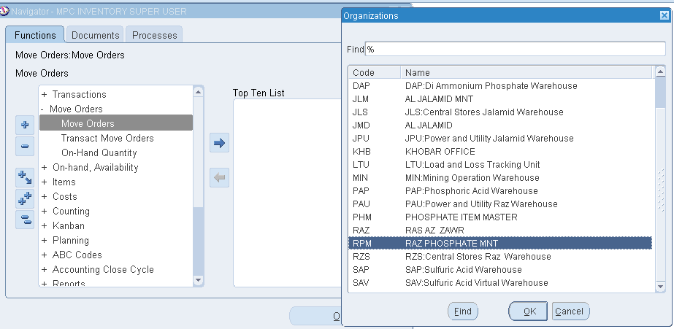

**2.Move order Screen.**

Move order number – <Tab>

ON tab -auto generated (28327069 )

Enter below MANUAL: Header & line information data entry:

Move order type =Requisition <not required to enter as it is already populated>

Transaction type=Move Order Transfer

Source Sub inventory= MAIN

Destination Sub inventory= Chem WH

ITEM = 1000134166

PRIMARY QTY=100

SOURCE LOCATOR = 003.86.30 < 089.56.58>

DESTINATION LOCATOR= CW.GR.01< CW.01.01>

Transfer Order Header=RI

Number- 18506590

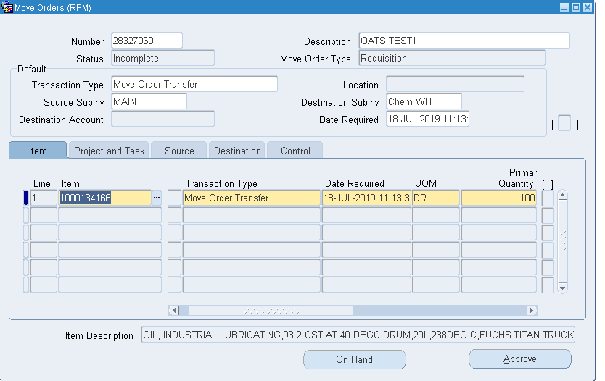

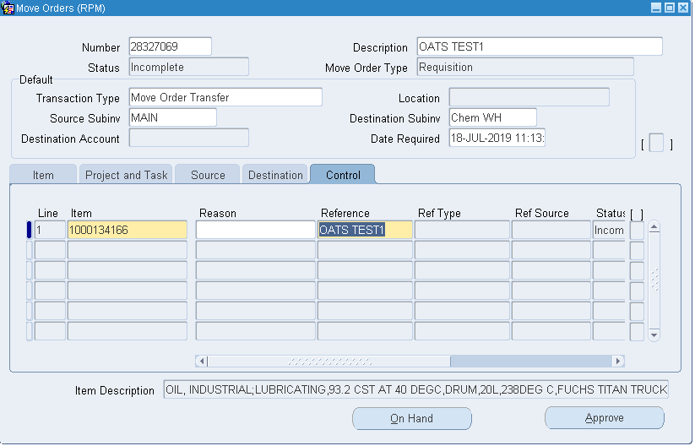

**3.Approval.**

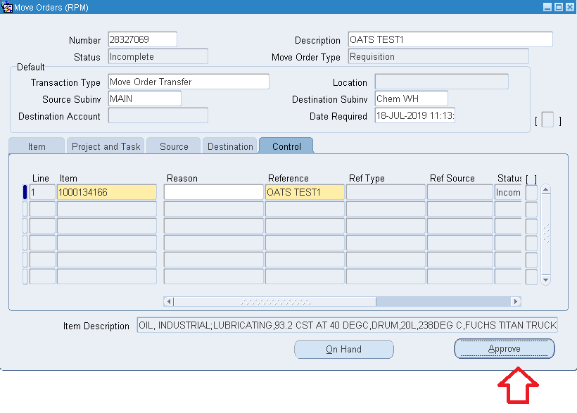

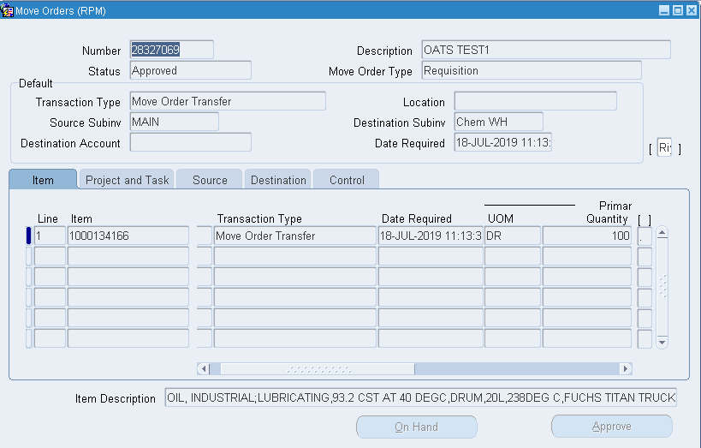

2. Move order Creation🡪Move Order Issue 🡪Move Order Approval

Responsibility:

MPC INVENTORY SUPERUSER

**1.Select Move order menu, Organization as RPM.**



**2.Move order Screen.**

ON tab -auto generated (28327070 )

Enter below MANUAL: Header & line information data entry:

Move order type =Requisition

Transaction type=Move Order Issue

Source Sub inventory= MAIN

Destination Account : 01.05.500.15.0000.1205.00000

ITEM = 1000134166

PRIMARY QTY=100

SOURCE LOCATOR = 003.86.30

DESTINATION Account: 01.05.500.15.0000.1205.00000

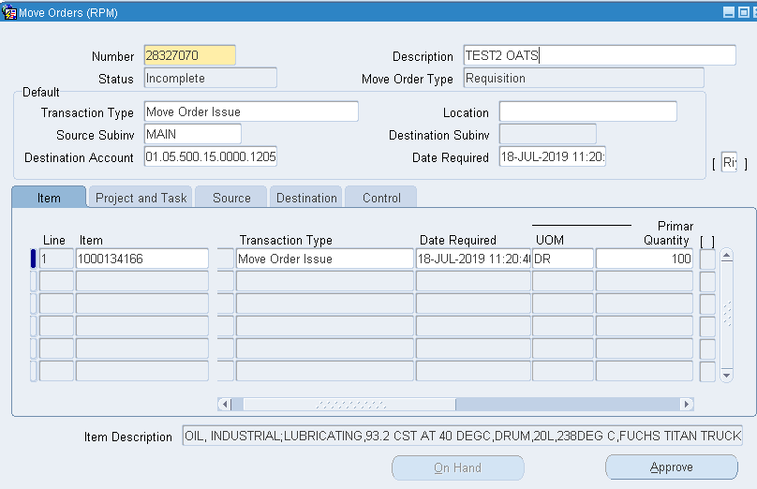

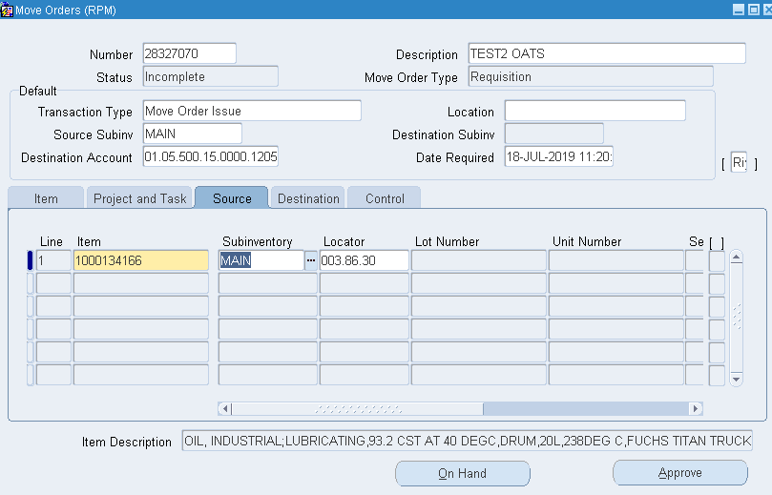

**3.Approval.**

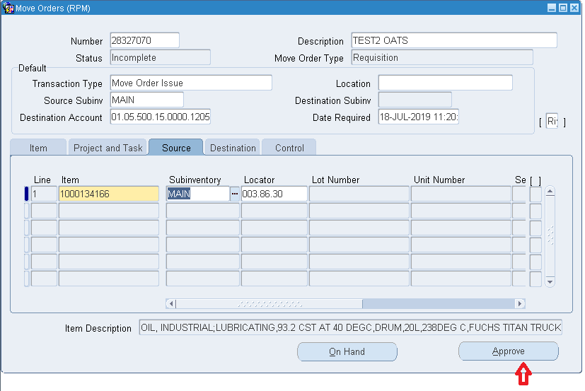

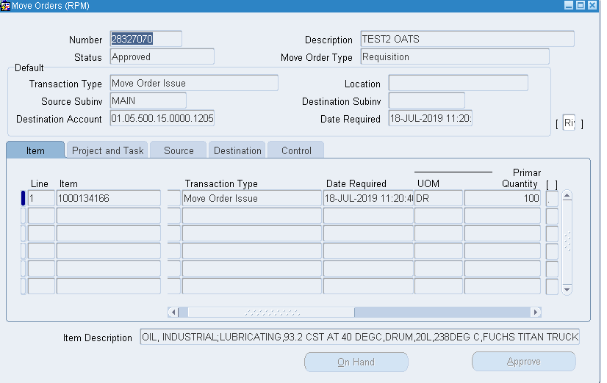

3.Move order approval -🡪Move order Allocation-🡪 Transact Move order

Responsibility:

MPC Inventory SUPER USER

**1.Select Transact Move order menu, Organization as RMP**

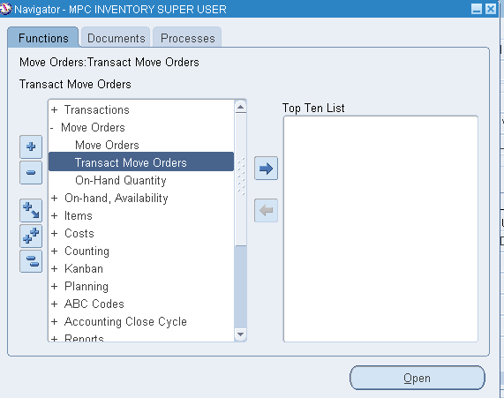

**2.Find MOVE ORDER Numbers.**

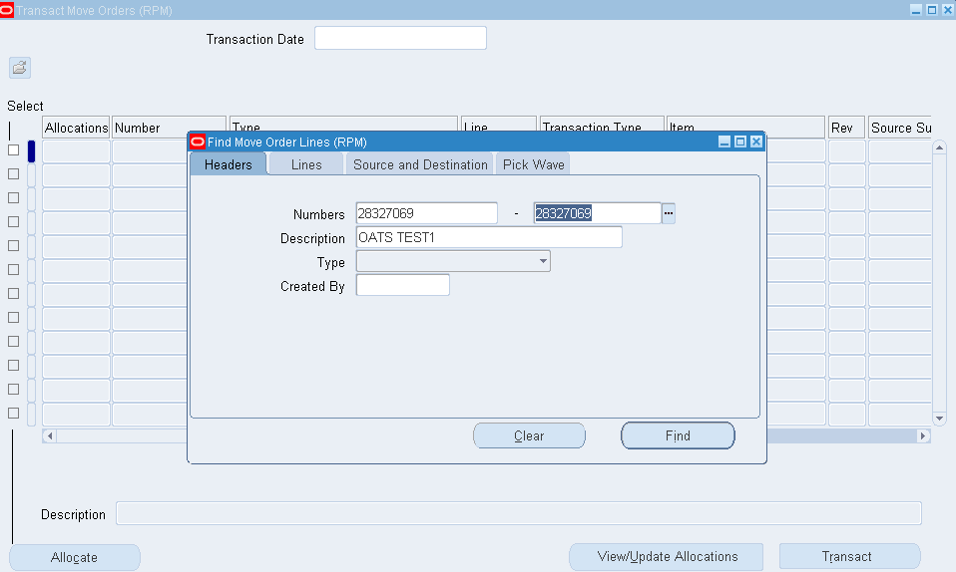

**3.Move order allocation.**

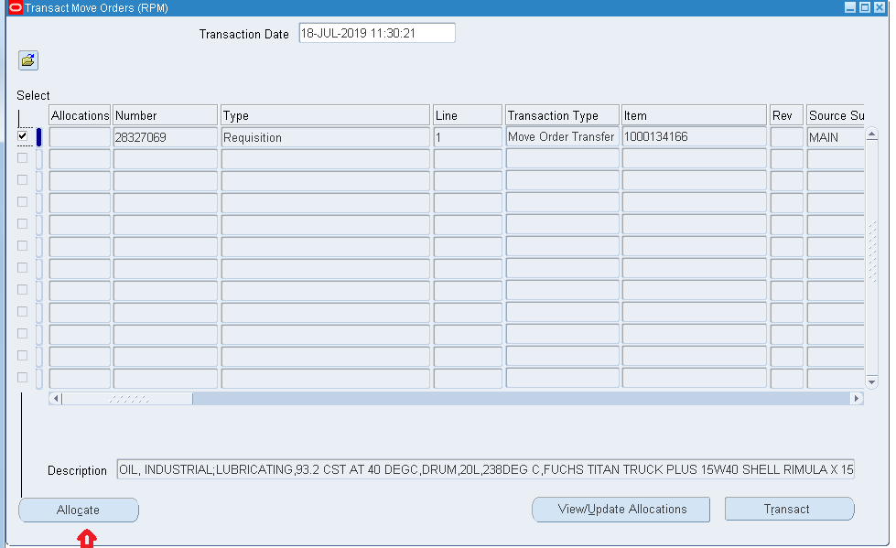

**4.Transact MOVE ORDER**

